# DAD 220 Cardinality and Targeted Data Template

Replace the bracketed text in this template with your screenshots and responses. Then submit it to the Module Four Lab for submission, grading, and feedback. Screenshots should be sized to approximately one quarter of a page. Written responses should be in complete sentences. Rename this document by adding your last name to the file name before you submit.

1. **Retrieve employee tuples and identify the number of employees** in San Francisco and New York.
   1. Text

      Description automatically generated
   2. 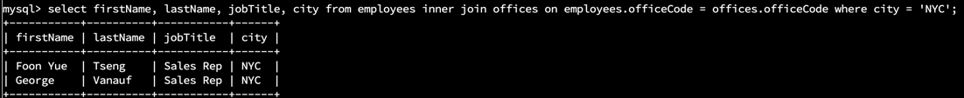
2. **Retrieve order details** for orderNumber 10330, 10338, and 10194 and **identify** what **type of cardinality** this represents in the entity relationship model.
   1. Text

      Description automatically generated
   2. Text

      Description automatically generated
   3. A picture containing table

      Description automatically generated
   4. The cardinality between the order and order details is a one-to-many relationship.
3. **Delete records** from the payments table where the customer number equals 103.
   1. Text

      Description automatically generated with low confidence (before delete).
   2.  (after delete).
4. **Retrieve customer records** for sales representative Barry Jones and **identify** if the **relationships** are one-to-one or one-to-many**.**
   1. Graphical user interface, text

      Description automatically generated with medium confidence
   2. The relationship is one-to-many. Barry Jones can assist multiple customers.
5. **Retrieve records** for customers who reside in Massachusetts and **identify** **their sales rep and the relationship of entities**. Identify if these entities demonstrate one-to-one or many-to-many relationships.
   1. Graphical user interface

      Description automatically generated
   2. This is a many-to-many relationship. Many customers can have multiple sales representatives.
6. **Add one customer record** with your last name using an INSERT statement. You may use the name of a celebrity or fictional character if you don’t use your own name.
   1. Command: insert into customers values (497, 'Wakkos and Things', 'Szlykowicz', 'Alexa', 8055557866, 'Computer Science Way', NULL, 'Las Vegas', 'NV', 12345, 'USA', 1401, 70000);
   2. A screen shot of a computer

      Description automatically generated with low confidence
   3. My new customer record is customerNumber = 497
7. **Reflection**
   1. **Define how cardinality is applied** to the databases you’ve been working with and why different numbers of records returned from the different offices.
      1. Cardinality shows us the different relationships between tables. The relationship between these tables can be one-to-one, one-two-many, zero-to-one, etc.
   2. **Compare and contrast** the different **queries** you ran and how cardinality applies to them.
      1. First we queried which sales representatives are in San-Francisco. The results show us the cardinality is one-to-many. We can have many representatives in one city or state. The second query was the order description of order numbers 10330, 10338, and 10194. This shows a one-to-many relationship. Each order number can have multiple purchases. The third query shows that one customer number can make multiple payments. This shows a one-to-many relationship or a zero or one relationship. The fourth query shows a many-to-many relationship because many sale representatives can service many customers.
   3. **Describe two** of the crucial **benefits** **of cardinality** in this type of database.
      1. One benefit of cardinality is that it helps us define the relationships between tables. A second benefit is that it shows us the constraints each table may have. For example, only one customer can have one unique customer number. Two separate customers cannot have the same customer number.